**Arab Academy for Science and Technology**

**College of Language and Communication**

**ESP III (English for Engineering)**

**Technical Report Writing**

**Report title**

**(Technology In Football)**

**Submitted by:Mohamed ahmed moghazy**

**Department: computer**

**Reg #:19100650**

**Submitted to :ms yassmin feteha**

**Submitted on: 13/1/2021**

**Acknowledgments**

First of all , I would like to express my special thanks and gratitude to my best teacher Ms Yassmin Feteha for her patience and help to complete this report despite the difficulties of online learning and corona virus.

Secondly ,I am extremely grateful to my parents for their caring and sacrifices for educating and preparingme for my future.I am very thankful to my friends for their help to finish this report while I was infected twice in a month with the corona virus .They were always with me sending me tips and advices because I was extremely tired .

Finally, I would like to thank myself for not giving up and doing all my best to finish the report.

**Abstract**

Technology is the heart of life, without it the live will be dead . also football without technology is dead .Many technologies were involved in football and they are helpful but the most important things are VAR and GOAL line technology. Teams,audience ,and even referees’ needed something to reduce the mistakes that happens during games that cost them losing the match. These technologies decreased the mistakes during game and to have fair game and each team will take it’s all right . They are somehow expensive but it really worth it.

**Table of Content**

|  |  |
| --- | --- |
| title | Page |
| **Introduction** | 1 |
| **1- what is football** | 2 |
| **2.1Name of technologies**  **2.2 how every technology works**  **2.3 cost of each technology**  **3 -examples of one each technology**  **4- conclusion**  **5 -References** | 2,5  2,5  3,6  7  8  9 |
|  |  |
|  |  |
|  |  |
|  |  |
|  |  |

|  |
| --- |
| **Glossary** :  Fifa :federation international de football association .established in 1904 by seven nations to foster friendly relation among national associations ,confederations, and their official players.  Var :virtual assistance referee used in football matches .    Guage:to measure or to test  Offside : according to fifa’s rulebook, a player is offside when he passes his half side line and nearer to his opponents’ goal line than both the ball and the second last opponent.A violation will occur when he is an offside position at the same time the ball is being passed towards him. |

**1**

**1-Inroduction**

**Technology is now in our lives and our daily activities but how to be in a sport like football? technology is the set of knowledge, skills, and techniques through which humans change and use our environment to create tools and machines and anything. football is the most famous sport in the world, so how they will affect each other? The purpose of this topic is to clarify how can technology change the normal sport to be the most viewed sport and sponsors and businessmen invest in developing new things for this sport. In this report, we will discuss how it was before technology being involved in it and after the appearance of it and how it made this normal sport to become not only a sport but also its now some country's economy and some organizations main source of money.**

2

**1-what is football?**

Association football, more commonly known as football or soccer(in the USA), was invented in 1863 in England. Each team starts with 10 players+goalkeeper and 7 players on the bench with a rounded ball and 3 referees in the field. Each team is trying to score a goal to win the game that latest for 90 min.

2- What are the technologies that affected the sport?

Technology is revolutionizing the way we conceive football. The change within the way during which football teams optimize their performance, their training, and their encounters.

Today we want to review the latest technologies that have been incorporated and we will concentrate on the most important technologies which are: Var, Goal-line technology.

2.1:VAR:

2.2 It's the best option to help the referees during the game to decrease his mistakes during the game. It's about 2 referees in a room watching the match that is playing and when they see that the referee in the field made a wrong decision or he took a decision and wants to check if it is correct or no they stop the game and analyze it using computers and artificial technologies to say the correct decision. Now when and how it works?

first: when it works? Three main incidents and one administrative game-changing:

3

first one: goals: the role of var is to help the referee whether that the referee disallowed a goal to be scored for a reason or he awards a team goal and the var referees see that there is a thing that may cancel the goal.

Second: penalty decisions: to determine that it is a penalty in few seconds is hard so sometimes the referees' award penalties that are wrong so the var can interfere in the decision or the opposite thing may happen.

Third: direct red cards: The work of the VAR is to make sure that no wrong decisions are made in conjunction with sending off or not sending off a player.

Then the administrative game-changing: The referee cautions or sends off the wrong player, or is unsure which player should be sanctioned. The VAR will inform the referee in order that the right player are often disciplined.

Now how does it work? 3 main steps.

1st step: Incident occurs:

the referee informs the VAR, or the VAR recommends to the referee that a decision should be rechecked.

2nd step Review and advice by the VAR:

The video footage is reviewed by the VAR, who advises the referee via headset what the video shows.

#### 4

#### 

#### The var refeeres reviewing the action happend

3rd step: decision or action taken:

#### The referee has two options to do the first one is to go to video footage on the field to see the review of the action and discuss it with var referees or to wait until the var referees take the final decision and tell him to take the correct decision.

#### This picture shows the referee reviewing the action and discussing it the var referees

video assistant referee (2019)

5

2,3 For sure this huge technology wants a big amount of money to develop it and to make it updated with the new technology. In brazil, The cost of the use of VAR for a season was estimated at US$6.2 million (~ZAR 87 million) for a season, and the Brazilian Football Confederation (CBF), proposed a levy on each club to pay the total cost. Unless there is a significant reduction in the cost, it is unlikely that we will be seeing its use in the PSL or other African leagues soon. it's hard to afford it but it's worth it.

( The Video Assistant Referee (VAR): The patent-protected Technology Changing the Face of Football \n.d)

2.1.1 Goal-line technology:(GLT)

2.2.1 Location tech and soccer:

Goal-line technology is technology means of instantly determining whether the whole ball has crossed the road or not. The confirmation of the goal is transmitted within seconds to the special watch worn by the referee .now, what technology is used?

Camera-based: Several approved systems work with cameras that detect the ball and use software to guage the footage from all the cameras. In this way, the system can determine whether the whole of the ball has crossed the goal line . Currently licensed systems to work with seven cameras per goal installed as high up as possible within the stadium structure.

Magnetic fields: For a magnetic field system, cables are placed underground and around the goal. The ball also has electronic sensors in it. The interaction between the receptors within the ball

6

and therefore the magnetic fields created through the underground cables allow the software to calculate the precise position of the ball and determine when a goal has been scored.

This shows that the ball passed the line and it appears to the watch that the referee has said "GOAL"

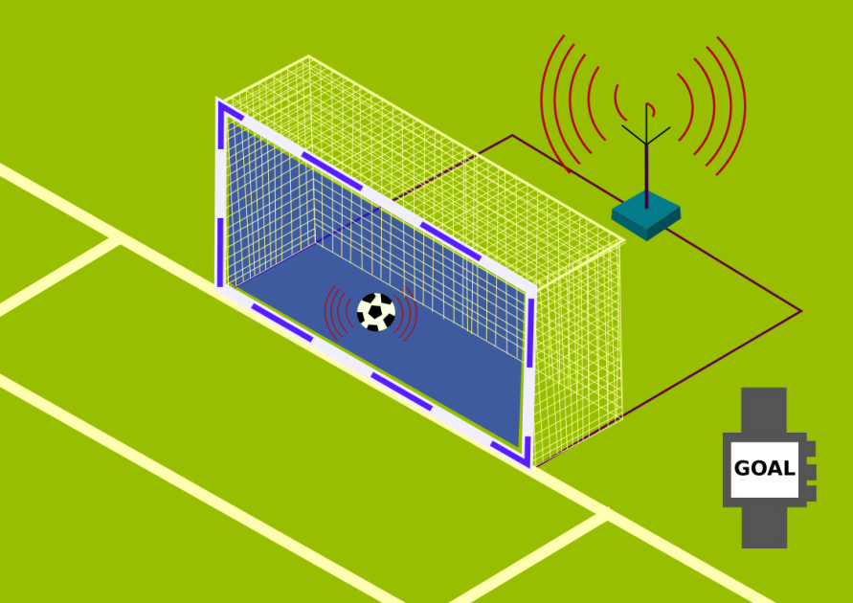

#### This shows that the ball passed the line and its appears to the watch that the referee has saying “GOAL”

Location tech and soccer: Goal-line technology is all about precise positioning ( 06/19/2018)

2.3.1 you may think it may be expensive, let's see. GoalControl is estimated to cost $260,000 per stadium and an addition $3,900 per game. This isn't pocket change, and for teams under financial pressure, GLT might not be an option. . Some leagues see that it's too expensive to afford it so

7

they decided to not use it but after a while, they are forced to use it because mistakes happen during games.

# Goal-Line Technology: A Source of Cost and Controversy(November 2013)

**3- Examples of each technology:**

In 2019, in the quarter-final of the champions league between Tottenham and Manchester City, in the 90th min, man city scored a goal, and the referee that there is a player from man city is offside and it was the winning goal. the var noticed that the player how scored the is offside then they reviewed it and told the referee its offside and he canceled the goal and Tottenham won the game.

In 2019 also, in the premier league between Liverpool and Manchester City, the defender of man city saved the ball on the line and it can be seen that the ball has passed the line but because of the goal-line technology, it didn't tell the referee its goal so the game continued and after the match, they reviewed the game and the decision was right and it wasn't a goal

8

4- **Conclusion**

Technology is the most important thing in our life, without it, you can't live you will difficulties. Also, football without technology is going to die. VAR and Goal-line technology made the sport with fewer mistakes and gives every team its write .becasue if the ball passed the line and the referee didn't see it, this technology informs him that the ball passed the line, or decision took it wrong the var will correct his decision. Therefore .technology is important in football like anything else in our life.

9

**5- References**

1 video assistant referee (2019 retrieved from)-<https://football-technology.fifa.com/en/media-tiles/video-assistant-referee-var/>

# [2- ( The Video Assistant Referee (VAR): The Patent-Protected Technology Changing the Face of Football retrieved from](2- ( The Video Assistant Referee (VAR): The Patent-Protected Technology Changing the Face of Football retrieved fromhttp://ip-unit.org/2019/world-ip-day-the-video-assistant-referee-var-the-patent-protected-technology-changing-the-face-of-football/)

# [http://ip-unit.org/2019/world-ip-day-the-video-assistant-referee-var-the-patent-protected-technology-changing-the-face-of-football/](2- ( The Video Assistant Referee (VAR): The Patent-Protected Technology Changing the Face of Football retrieved fromhttp://ip-unit.org/2019/world-ip-day-the-video-assistant-referee-var-the-patent-protected-technology-changing-the-face-of-football/)

3-Location tech and soccer: Goal-line technology is all about precise positioning ( 06/19/2018) retrieved from <https://www.geospatialworld.net/blogs/goal-line-technology-precise-positioning/>

# [4 Goal-Line Technology: A Source of Cost and Controversy (november 2013)](https://sites.duke.edu/wcwp/2013/11/05/goal-line-technology-a-source-of-cost-and-controversy/" \l ":~:text=GoalControl%20is%20estimated%20to%20cost,an%20addition%20%243%2C900%20per%20game)

[retrieved from -](https://sites.duke.edu/wcwp/2013/11/05/goal-line-technology-a-source-of-cost-and-controversy/" \l ":~:text=GoalControl%20is%20estimated%20to%20cost,an%20addition%20%243%2C900%20per%20game)**[https://sites.duke.edu/wcwp/2013/11/05/goal-line-technology-a-source-of-cost-and-controversy/#:~:text=GoalControl%20is%20estimated%20to%20cost,an%20addition%20%243%2C900%20per%20game](https://sites.duke.edu/wcwp/2013/11/05/goal-line-technology-a-source-of-cost-and-controversy/" \l ":~:text=GoalControl%20is%20estimated%20to%20cost,an%20addition%20%243%2C900%20per%20game)**